UNITED STATES
SECURITIES AND EXCHANGE COMMISSION
Washington, D.C. 20549
______________________

FORM 8-K

CURRENT REPORT
Pursuant to Section 13 or 15(d) of the
Securities Exchange Act of 1934
______________________

Date of Report (Date of earliest event reported): August 4, 2026
OrthoPediatrics Corp.
(Exact name of registrant as specified in its charter)
Delaware
(State or other jurisdiction of incorporation)
001-38242 |  |  | 26-1761833
(Commission File Number) |  |  | (I.R.S. Employer Identification Number)
2850 Frontier Drive  Warsaw, Indiana |  |  | 46582
(Address of principal executive offices) |  |  | (Zip Code)

Registrant’s telephone number, including area code: (574) 268-6379
Not Applicable
(Former name or former address, if changed since last report)
Securities registered pursuant to Section 12(b) of the Act:
Title of Each Class |  |  |  |  |  | Trading Symbol(s) |  |  |  |  |  | Name of each exchange on which registered
Common Stock, $0.00025 par value per share |  |  |  |  |  | KIDS |  |  |  |  |  | Nasdaq Global Market

Check the appropriate box below if the Form 8-K filing is intended to simultaneously satisfy the filing obligation of the registrant under any of the following provisions:
☐ |  |  | Written communications pursuant to Rule 425 under the Securities Act (17 CFR 230.425)
☐ |  |  | Soliciting material pursuant to Rule 14a-12 under the Exchange Act (17 CFR 240.14a-12)
☐ |  |  | Pre-commencement communications pursuant to Rule 14d-2(b) under the Exchange Act (17 CFR 240.14d-2(b))
☐ |  |  | Pre-commencement communications pursuant to Rule 13e-4(c) under the Exchange Act (17 CFR 240.13e-4(c))
Indicate by check mark whether the registrant is an emerging growth company as defined in Rule 405 under the Securities Act (17 CFR 230.405) or Rule 12b-2 under the Exchange Act (17 CFR 240.12b-2).
Emerging growth company ☐
If an emerging growth company, indicate by check mark if the registrant has elected not to use the extended transition period for complying with any new or revised financial accounting standards provided pursuant to Section 13(a) of the Exchange Act ☐

Item 7.01. Regulation FD Disclosure.

The executive officers of OrthoPediatrics Corp. have several upcoming presentations to representatives of investors and analysts. The officers intend to use the material filed as Exhibit 99.1 herewith, in whole or in part, as part of those presentations.

The information in this Item 7.01, including the information incorporated by reference herein from Exhibit 99.1, is furnished pursuant to Item 7.01 of Form 8-K and shall not be deemed “filed” for purposes of Section 18 of the Securities Exchange Act of 1934, as amended (the “Exchange Act”), or incorporated by reference in any filing under the Securities Act of 1933, as amended, or the Exchange Act, except as shall be expressly set forth by specific reference in such a filing.

Item 9.01. Financial Statements and Exhibits.
(d) |  |  | Exhibits
 |  |  | Exhibit No. |  |  | Description
 |  |  | 99.1 |  |  | OrthoPediatrics Corp. Investor Presentation dated August 2026
 |  |  | 104 |  |  | Cover Page Interactive Data File (embedded within the Inline XBRL document).
* * * * * *

SIGNATURE

Pursuant to the requirements of the Securities Exchange Act of 1934, the Registrant has duly caused this report to be signed on its behalf by the undersigned hereunto duly authorized.
 |  |  | OrthoPediatrics Corp.
Date: August 4, 2026 |  |  | By: |  |  | /s/ Daniel J. Gerritzen
Daniel J. Gerritzen,
General Counsel and Secretary



- 2 -
2026 Investor Presentation www.OrthoPediatrics.com

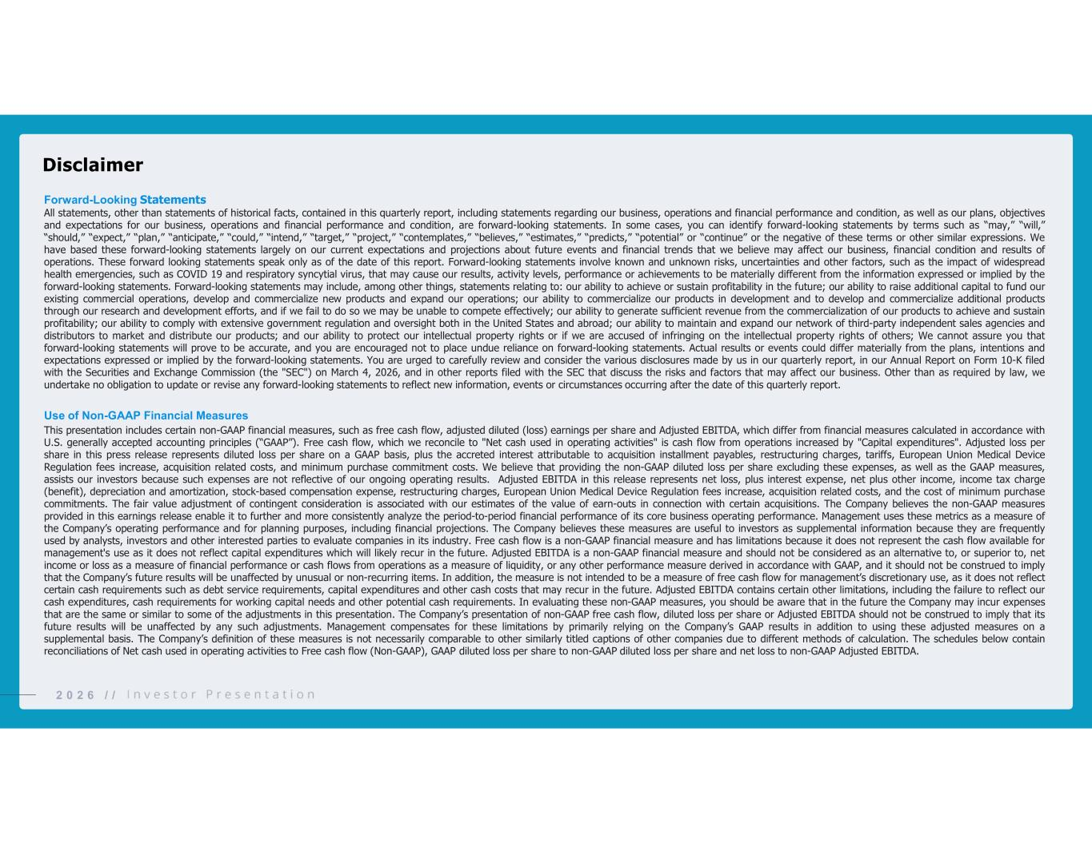
22 0 2 6 / / Forward-Looking Statements All statements, other than statements of historical facts, contained in this quarterly report, including statements regarding our business, operations and financial performance and condition, as well as our plans, objectives and expectations for our business, operations and financial performance and condition, are forward-looking statements. In some cases, you can identify forward-looking statements by terms such as “may,” “will,” “should,” “expect,” “plan,” “anticipate,” “could,” “intend,” “target,” “project,” “contemplates,” “believes,” “estimates,” “predicts,” “potential” or “continue” or the negative of these terms or other similar expressions. We have based these forward-looking statements largely on our current expectations and projections about future events and financial trends that we believe may affect our business, financial condition and results of operations. These forward looking statements speak only as of the date of this report. Forward-looking statements involve known and unknown risks, uncertainties and other factors, such as the impact of widespread health emergencies, such as COVID 19 and respiratory syncytial virus, that may cause our results, activity levels, performance or achievements to be materially different from the information expressed or implied by the forward-looking statements. Forward-looking statements may include, among other things, statements relating to: our ability to achieve or sustain profitability in the future; our ability to raise additional capital to fund our existing commercial operations, develop and commercialize new products and expand our operations; our ability to commercialize our products in development and to develop and commercialize additional products through our research and development efforts, and if we fail to do so we may be unable to compete effectively; our ability to generate sufficient revenue from the commercialization of our products to achieve and sustain profitability; our ability to comply with extensive government regulation and oversight both in the United States and abroad; our ability to maintain and expand our network of third-party independent sales agencies and distributors to market and distribute our products; and our ability to protect our intellectual property rights or if we are accused of infringing on the intellectual property rights of others; We cannot assure you that forward-looking statements will prove to be accurate, and you are encouraged not to place undue reliance on forward-looking statements. Actual results or events could differ materially from the plans, intentions and expectations expressed or implied by the forward-looking statements. You are urged to carefully review and consider the various disclosures made by us in our quarterly report, in our Annual Report on Form 10-K filed with the Securities and Exchange Commission (the "SEC") on March 4, 2026, and in other reports filed with the SEC that discuss the risks and factors that may affect our business. Other than as required by law, we undertake no obligation to update or revise any forward-looking statements to reflect new information, events or circumstances occurring after the date of this quarterly report. Use of Non-GAAP Financial Measures This presentation includes certain non-GAAP financial measures, such as free cash flow, adjusted diluted (loss) earnings per share and Adjusted EBITDA, which differ from financial measures calculated in accordance with U.S. generally accepted accounting principles (“GAAP”). Free cash flow, which we reconcile to "Net cash used in operating activities" is cash flow from operations increased by "Capital expenditures". Adjusted loss per share in this press release represents diluted loss per share on a GAAP basis, plus the accreted interest attributable to acquisition installment payables, restructuring charges, tariffs, European Union Medical Device Regulation fees increase, acquisition related costs, and minimum purchase commitment costs. We believe that providing the non-GAAP diluted loss per share excluding these expenses, as well as the GAAP measures, assists our investors because such expenses are not reflective of our ongoing operating results. Adjusted EBITDA in this release represents net loss, plus interest expense, net plus other income, income tax charge (benefit), depreciation and amortization, stock-based compensation expense, restructuring charges, European Union Medical Device Regulation fees increase, acquisition related costs, and the cost of minimum purchase commitments. The fair value adjustment of contingent consideration is associated with our estimates of the value of earn-outs in connection with certain acquisitions. The Company believes the non-GAAP measures provided in this earnings release enable it to further and more consistently analyze the period-to-period financial performance of its core business operating performance. Management uses these metrics as a measure of the Company’s operating performance and for planning purposes, including financial projections. The Company believes these measures are useful to investors as supplemental information because they are frequently used by analysts, investors and other interested parties to evaluate companies in its industry. Free cash flow is a non-GAAP financial measure and has limitations because it does not represent the cash flow available for management's use as it does not reflect capital expenditures which will likely recur in the future. Adjusted EBITDA is a non-GAAP financial measure and should not be considered as an alternative to, or superior to, net income or loss as a measure of financial performance or cash flows from operations as a measure of liquidity, or any other performance measure derived in accordance with GAAP, and it should not be construed to imply that the Company’s future results will be unaffected by unusual or non-recurring items. In addition, the measure is not intended to be a measure of free cash flow for management’s discretionary use, as it does not reflect certain cash requirements such as debt service requirements, capital expenditures and other cash costs that may recur in the future. Adjusted EBITDA contains certain other limitations, including the failure to reflect our cash expenditures, cash requirements for working capital needs and other potential cash requirements. In evaluating these non-GAAP measures, you should be aware that in the future the Company may incur expenses that are the same or similar to some of the adjustments in this presentation. The Company’s presentation of non-GAAP free cash flow, diluted loss per share or Adjusted EBITDA should not be construed to imply that its future results will be unaffected by any such adjustments. Management compensates for these limitations by primarily relying on the Company’s GAAP results in addition to using these adjusted measures on a supplemental basis. The Company’s definition of these measures is not necessarily comparable to other similarly titled captions of other companies due to different methods of calculation. The schedules below contain reconciliations of Net cash used in operating activities to Free cash flow (Non-GAAP), GAAP diluted loss per share to non-GAAP diluted loss per share and net loss to non-GAAP Adjusted EBITDA. Disclaimer

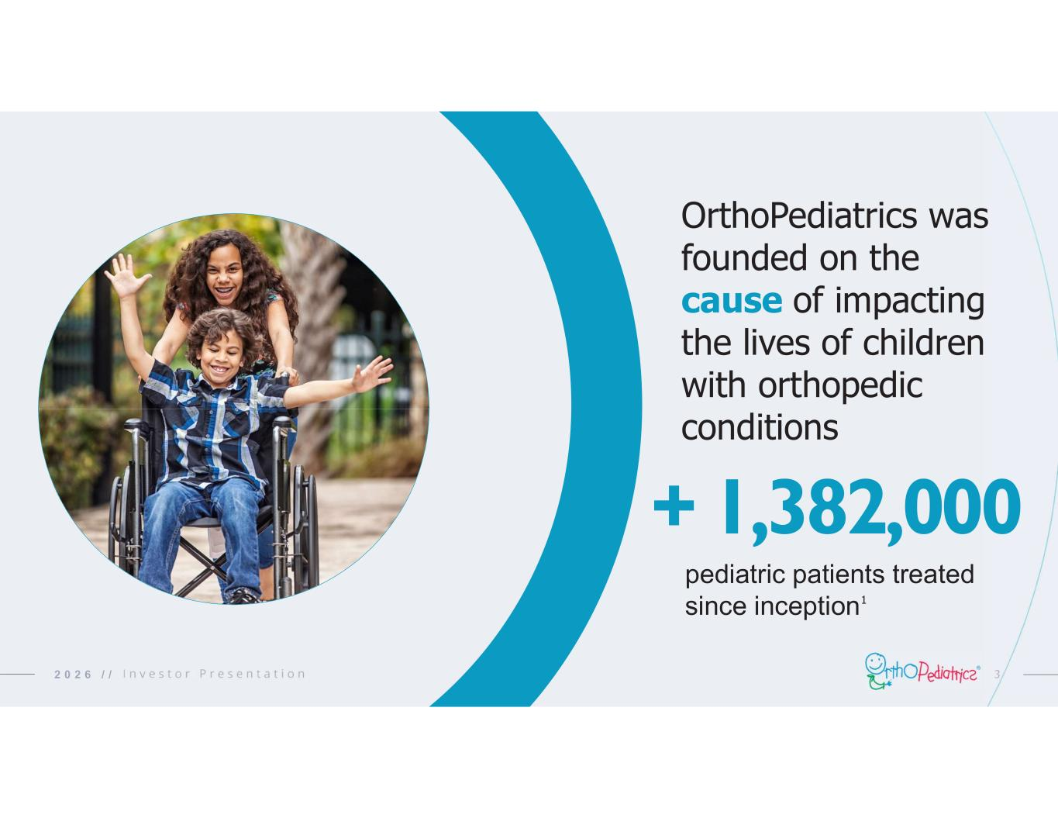
32 0 2 6 / / pediatric patients treated since inception + 1,382,000 OrthoPediatrics was founded on the cause of impacting the lives of children with orthopedic conditions 1

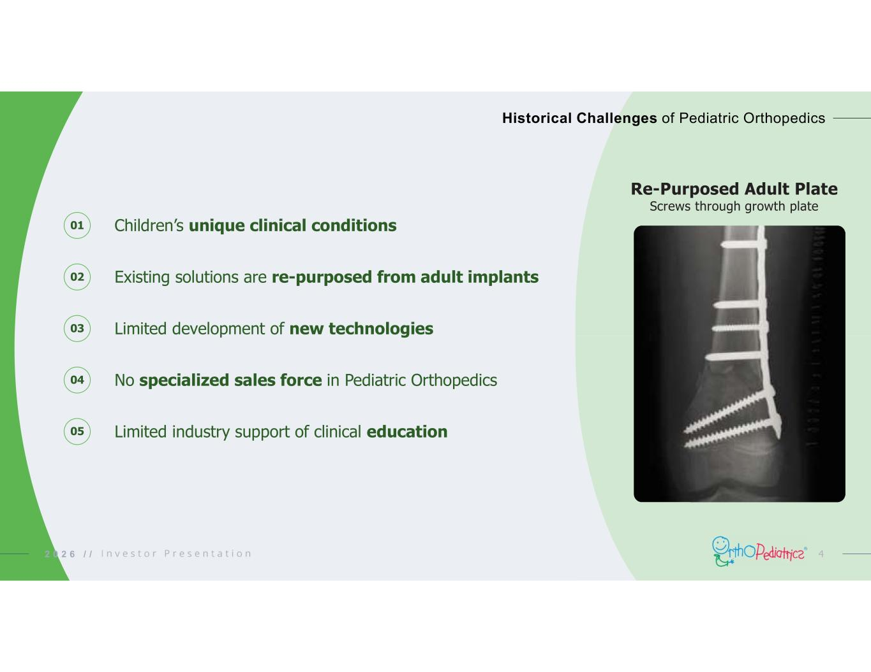
01 Children’s unique clinical conditions Existing solutions are re-purposed from adult implants Limited development of new technologies No specialized sales force in Pediatric Orthopedics Limited industry support of clinical education 02 03 04 05 42 0 2 6 / / Historical Challenges of Pediatric Orthopedics Re-Purposed Adult Plate Screws through growth plate

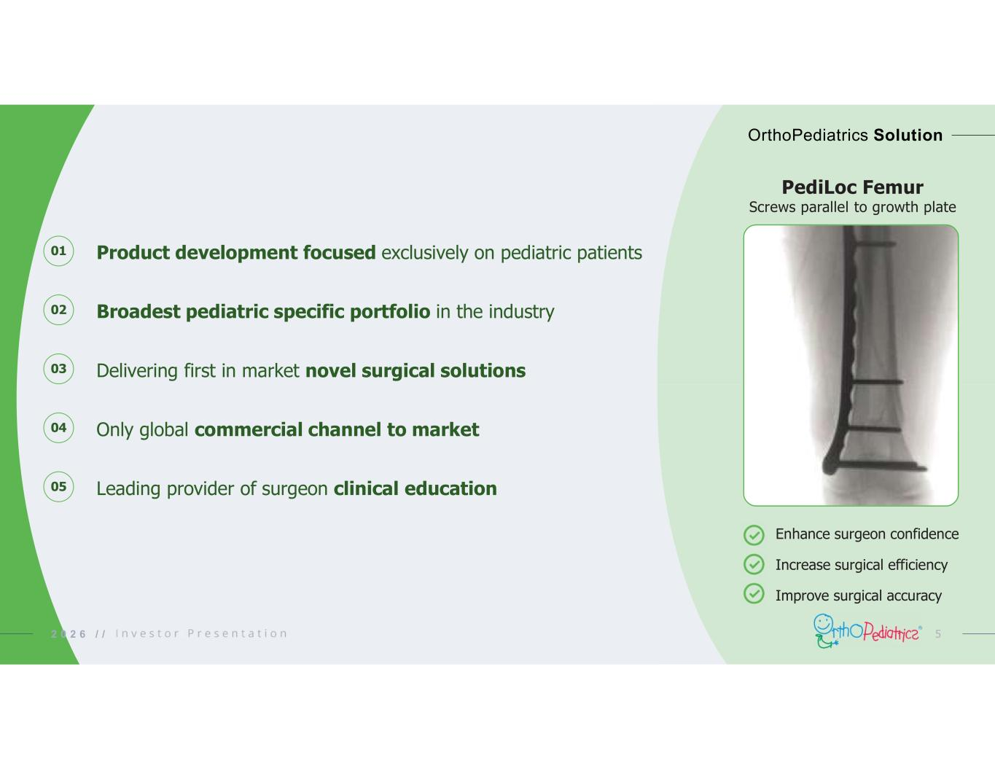
52 0 2 6 / / OrthoPediatrics Solution 01 02 03 04 05 Product development focused exclusively on pediatric patients Broadest pediatric specific portfolio in the industry Delivering first in market novel surgical solutions Only global commercial channel to market Leading provider of surgeon clinical education PediLoc Femur Screws parallel to growth plate Enhance surgeon confidence Increase surgical efficiency Improve surgical accuracy

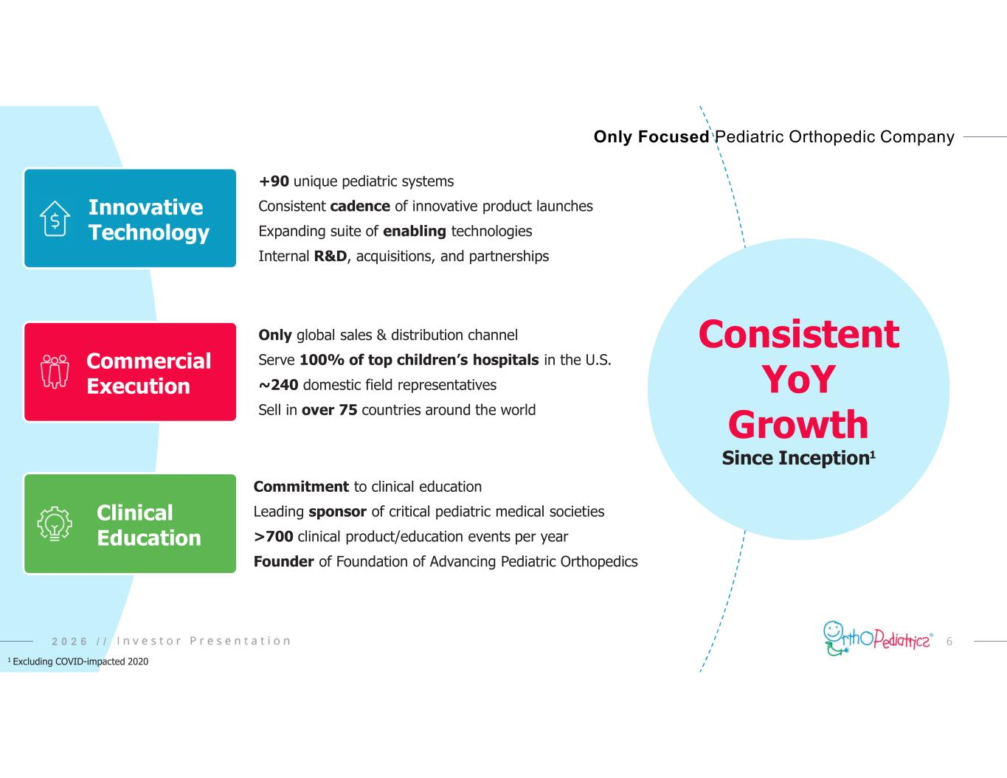
62 0 2 6 / / Only Focused Pediatric Orthopedic Company Consistent YoY Growth Since Inception 1 Excluding COVID-impacted 2020 +90 unique pediatric systems Consistent cadence of innovative product launches Expanding suite of enabling technologies Internal R&D, acquisitions, and partnerships Only global sales & distribution channel Serve 100% of top children’s hospitals in the U.S. ~240 domestic field representatives Sell in over 75 countries around the world Commitment to clinical education Leading sponsor of critical pediatric medical societies >700 clinical product/education events per year Founder of Foundation of Advancing Pediatric Orthopedics Innovative Technology Commercial Execution Clinical Education 1

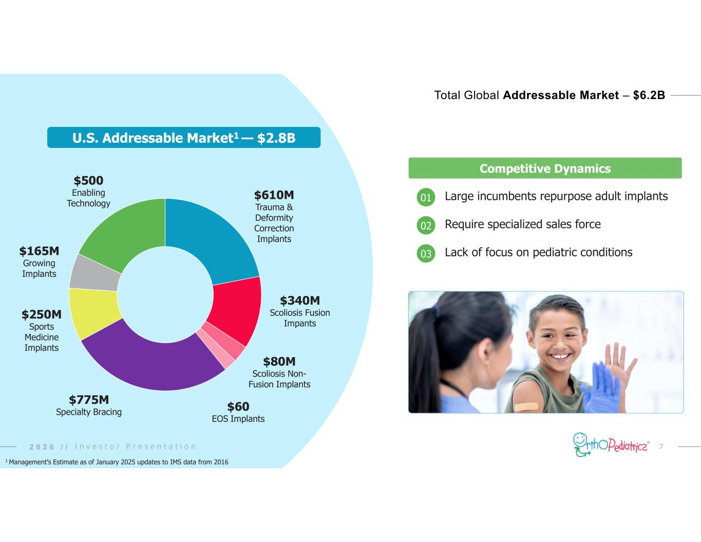
72 0 2 6 / / Total Global Addressable Market – $6.2B Competitive Dynamics $610M Trauma & Deformity Correction Implants $340M Scoliosis Fusion Impants $80M Scoliosis Non- Fusion Implants $60 EOS Implants $775M Specialty Bracing $250M Sports Medicine Implants $165M Growing Implants $500 Enabling Technology Large incumbents repurpose adult implants Require specialized sales force Lack of focus on pediatric conditions 01 02 03 U.S. Addressable Market1 — $2.8B 2 0 2 6 / / 1 Management’s Estimate as of January 2025 updates to IMS data from 2016

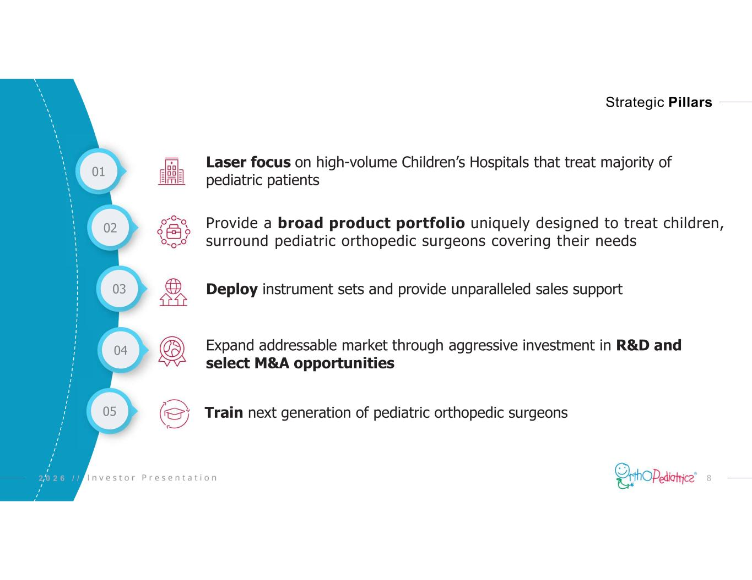
82 0 2 6 / / Strategic Pillars 02 Provide a broad product portfolio uniquely designed to treat children, surround pediatric orthopedic surgeons covering their needs 04 Expand addressable market through aggressive investment in R&D and select M&A opportunities 05 Train next generation of pediatric orthopedic surgeons 03 Deploy instrument sets and provide unparalleled sales support 01 Laser focus on high-volume Children’s Hospitals that treat majority of pediatric patients

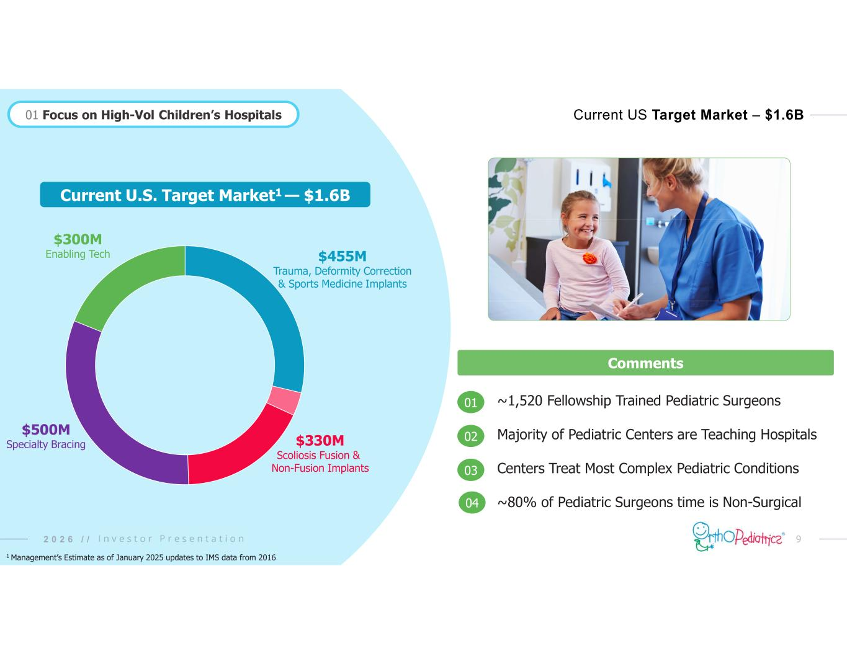
92 0 2 6 / / Comments ~1,520 Fellowship Trained Pediatric Surgeons Majority of Pediatric Centers are Teaching Hospitals Centers Treat Most Complex Pediatric Conditions ~80% of Pediatric Surgeons time is Non-Surgical 01 02 03 01 Focus on High-Vol Children’s Hospitals Current US Target Market – $1.6B 04 1 Management’s Estimate as of January 2025 updates to IMS data from 2016 $455M Trauma, Deformity Correction & Sports Medicine Implants $330M Scoliosis Fusion & Non-Fusion Implants $500M Specialty Bracing $300M Enabling Tech Current U.S. Target Market1 — $1.6B

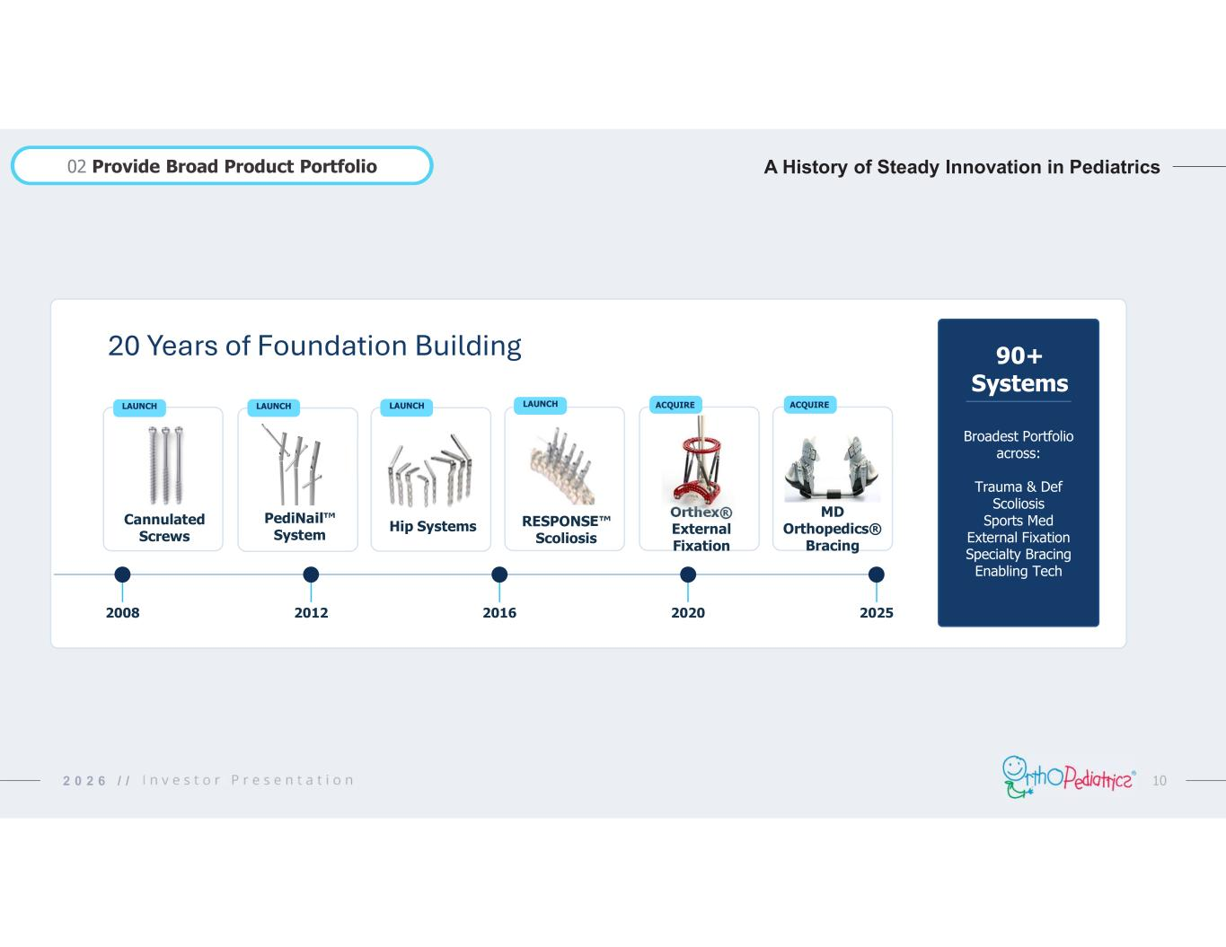
102 0 2 6 / / 20 Years of Foundation Building Cannulated Screws 2008 PediNail System 2012 RESPONSE Scoliosis 2016 Orthex® External Fixation 2020 MD Orthopedics® Bracing 2025 LAUNCHLAUNCH LAUNCH ACQUIRE Hip Systems LAUNCH ACQUIRE 90+ Systems Broadest Portfolio across: Trauma & Def Scoliosis Sports Med External Fixation Specialty Bracing Enabling Tech A History of Steady Innovation in Pediatrics02 Provide Broad Product Portfolio

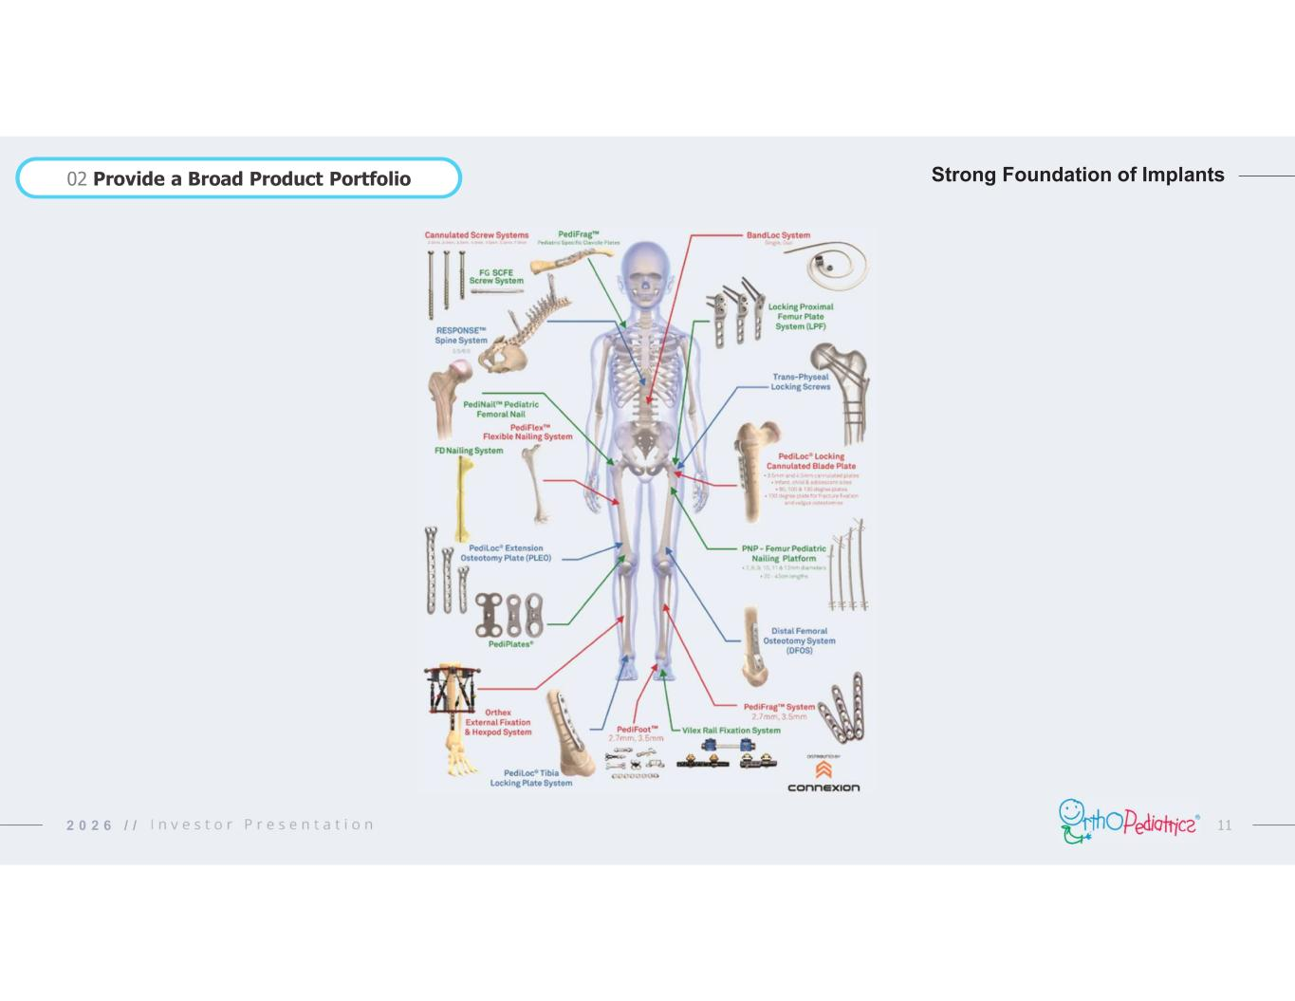
112 0 2 6 / / 02 Provide a Broad Product Portfolio Strong Foundation of Implants

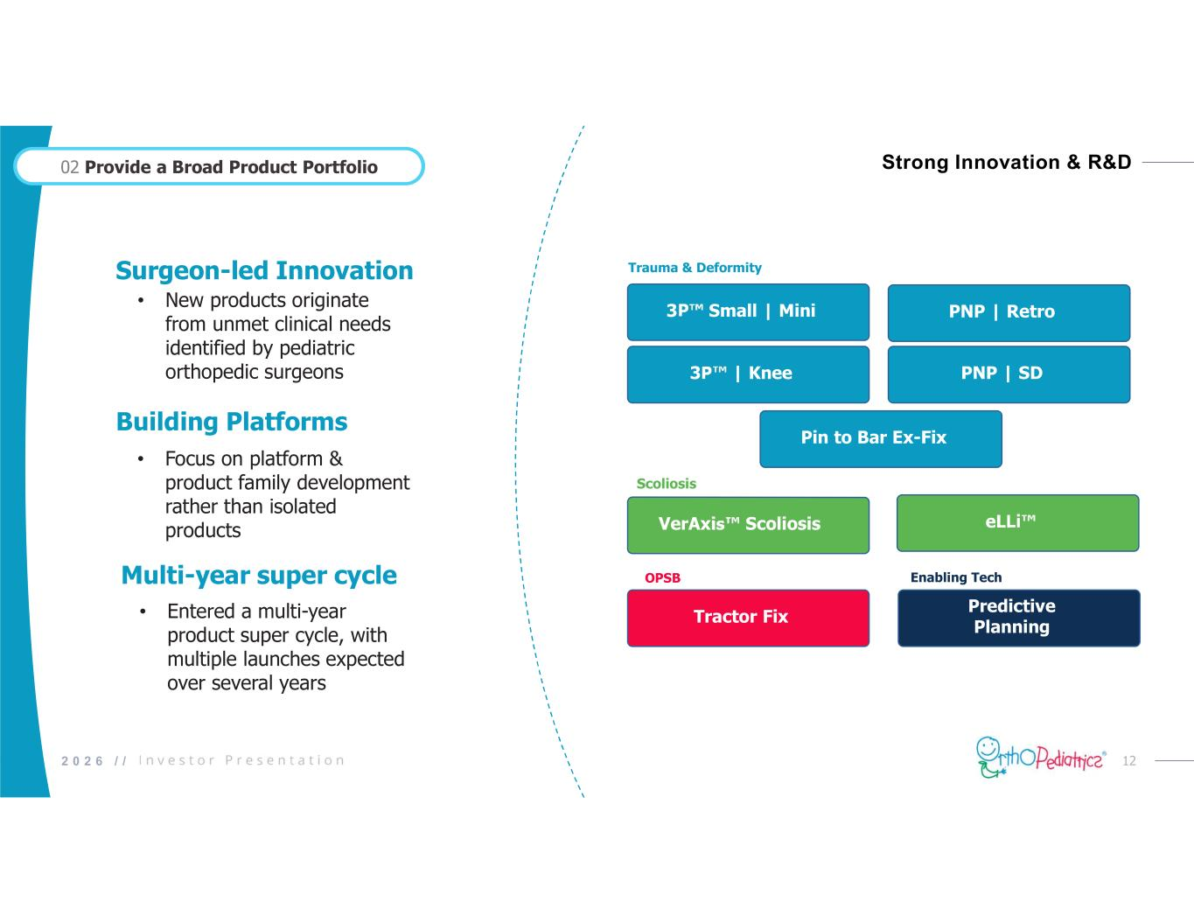
122 0 2 6 / / Strong Innovation & R&D 02 Provide a Broad Product Portfolio Multi-year super cycle • Entered a multi-year product super cycle, with multiple launches expected over several years Building Platforms • Focus on platform & product family development rather than isolated products Surgeon-led Innovation • New products originate from unmet clinical needs identified by pediatric orthopedic surgeons eLLi 3P Small | Mini PNP | SD Tractor Fix 3P | Knee Predictive Planning PNP | Retro Pin to Bar Ex-Fix VerAxis Scoliosis Scoliosis Trauma & Deformity OPSB Enabling Tech

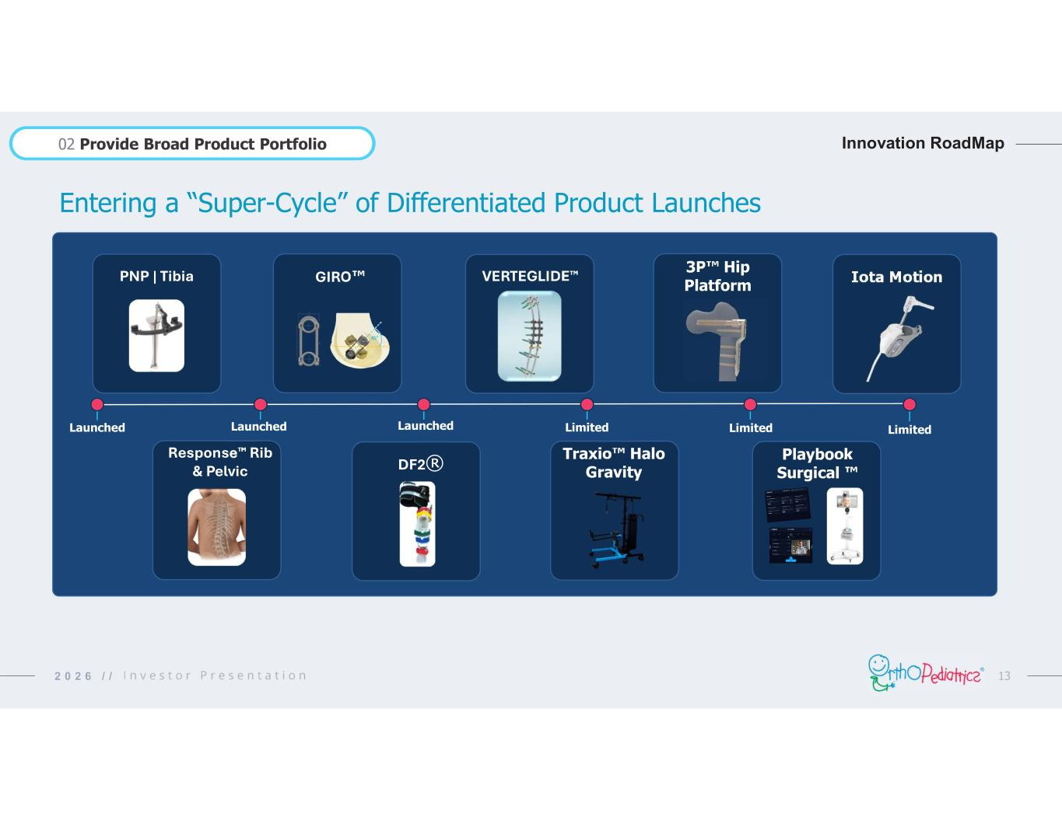
132 0 2 6 / / Innovation RoadMap02 Provide Broad Product Portfolio Playbook Surgical Response Rib & Pelvic PNP | Tibia Limited Iota Motion DF2® 3P Hip PlatformGIRO VERTEGLIDE Traxio Halo Gravity Entering a “Super-Cycle” of Differentiated Product Launches LimitedLimitedLaunchedLaunchedLaunched

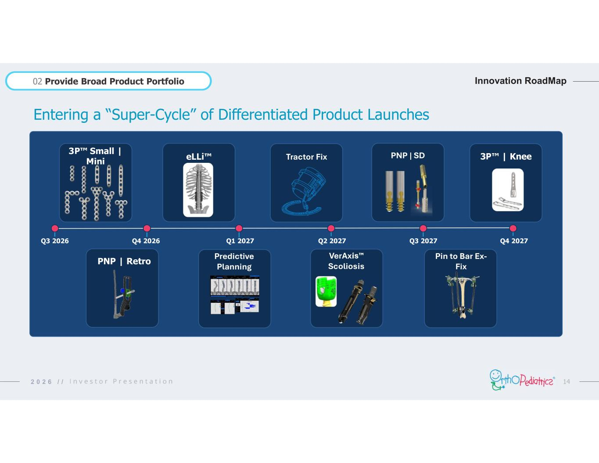
142 0 2 6 / / Innovation RoadMap02 Provide Broad Product Portfolio Entering a “Super-Cycle” of Differentiated Product Launches PNP | Retro 3P Small | Mini Predictive Planning eLLi Tractor Fix VerAxis Scoliosis PNP | SD Pin to Bar Ex- Fix 3P | Knee Q3 2026 Q4 2026 Q1 2027 Q2 2027 Q3 2027 Q4 2027

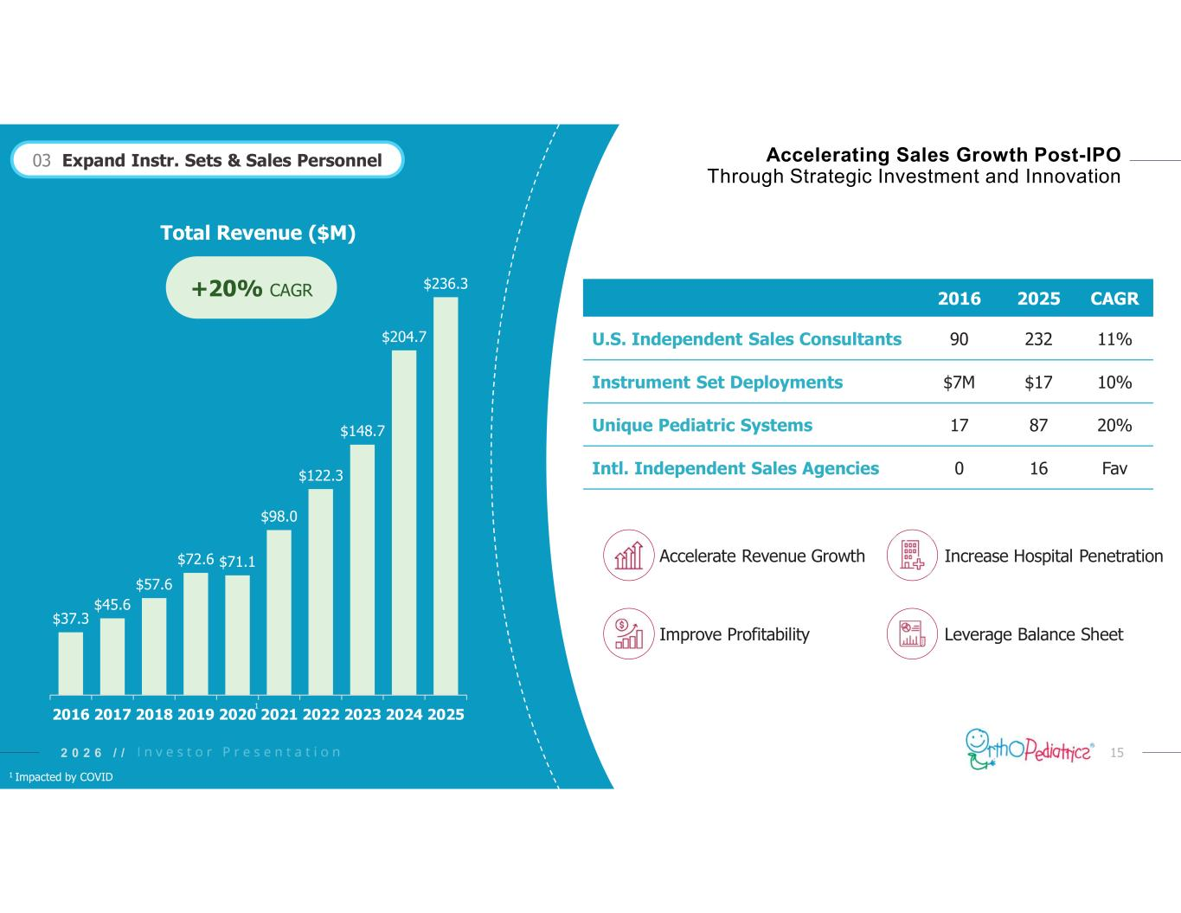
152 0 2 6 / / Accelerating Sales Growth Post-IPO Through Strategic Investment and Innovation $37.3 $45.6 $57.6 $72.6 $71.1 $98.0 $122.3 $148.7 $204.7 $236.3 2016 2017 2018 2019 2020 2021 2022 2023 2024 2025 Total Revenue ($M) CAGR20252016 11%23290U.S. Independent Sales Consultants 10%$17$7MInstrument Set Deployments 20%8717Unique Pediatric Systems Fav160Intl. Independent Sales Agencies Increase Hospital PenetrationAccelerate Revenue Growth Improve Profitability Leverage Balance Sheet +20% CAGR 03 Expand Instr. Sets & Sales Personnel 1 1 Impacted by COVID

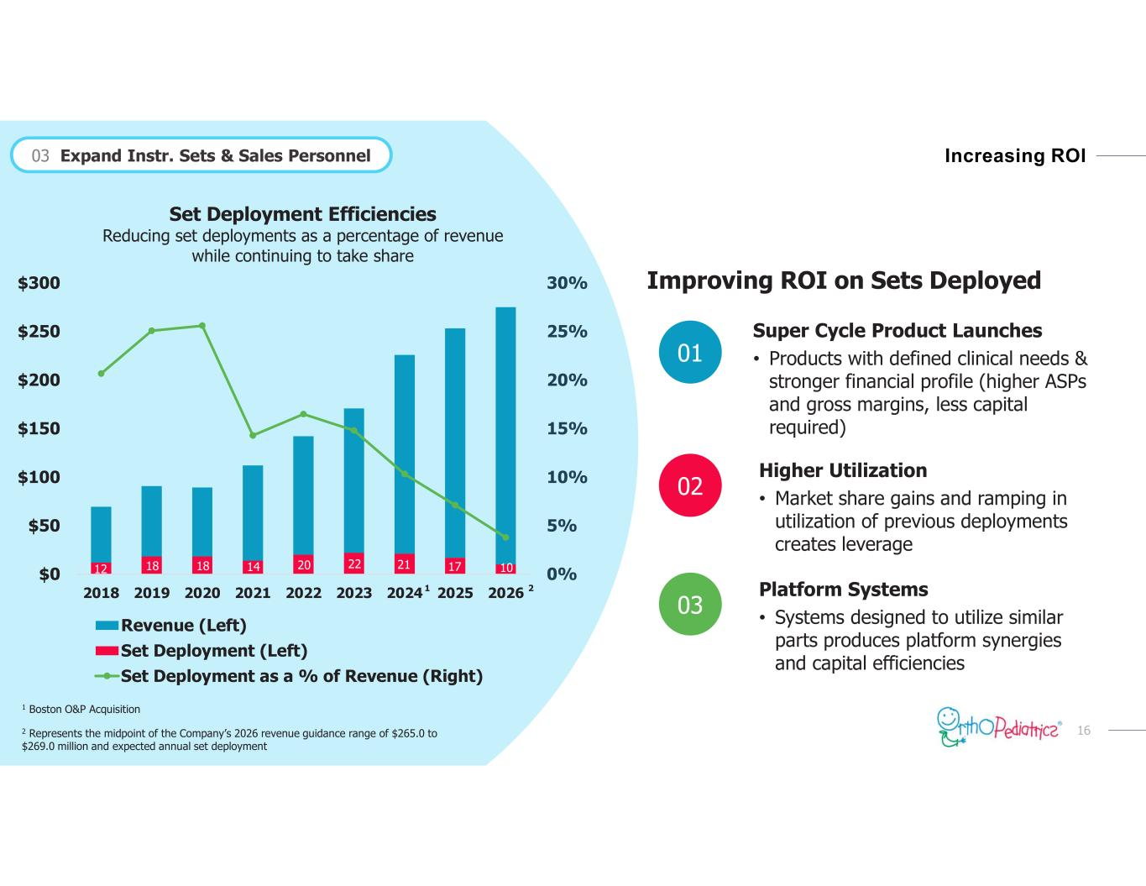
162 0 2 6 / / Increasing ROI 12 18 18 14 20 22 21 17 10 0% 5% 10% 15% 20% 25% 30% $0 $50 $100 $150 $200 $250 $300 2018 2019 2020 2021 2022 2023 2024 2025 2026 Set Deployment Efficiencies Reducing set deployments as a percentage of revenue while continuing to take share Revenue (Left) Set Deployment (Left) Set Deployment as a % of Revenue (Right) 2 Represents the midpoint of the Company’s 2026 revenue guidance range of $265.0 to $269.0 million and expected annual set deployment Improving ROI on Sets Deployed Super Cycle Product Launches • Products with defined clinical needs & stronger financial profile (higher ASPs and gross margins, less capital required) Platform Systems • Systems designed to utilize similar parts produces platform synergies and capital efficiencies Higher Utilization • Market share gains and ramping in utilization of previous deployments creates leverage 02 03 01 2 03 Expand Instr. Sets & Sales Personnel 1 1 Boston O&P Acquisition

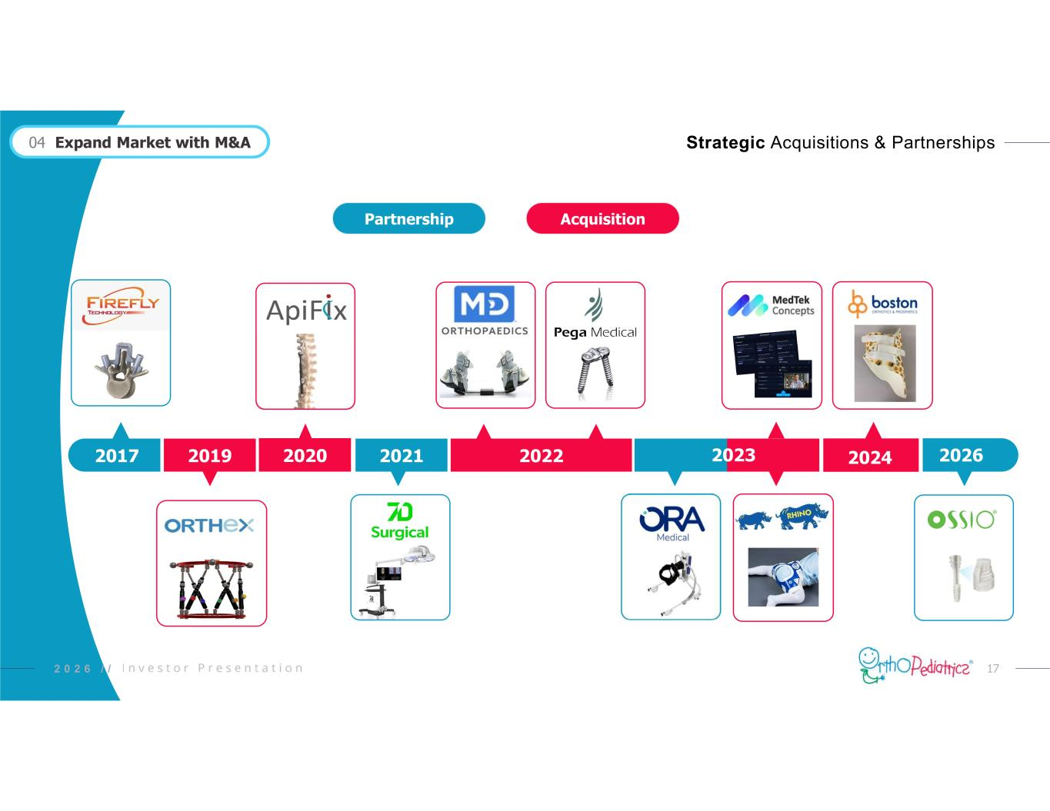
172 0 2 6 / / Strategic Acquisitions & Partnerships 202020192017 2022 04 Expand Market with M&A 2021 2023 2024 2026 Partnership Acquisition

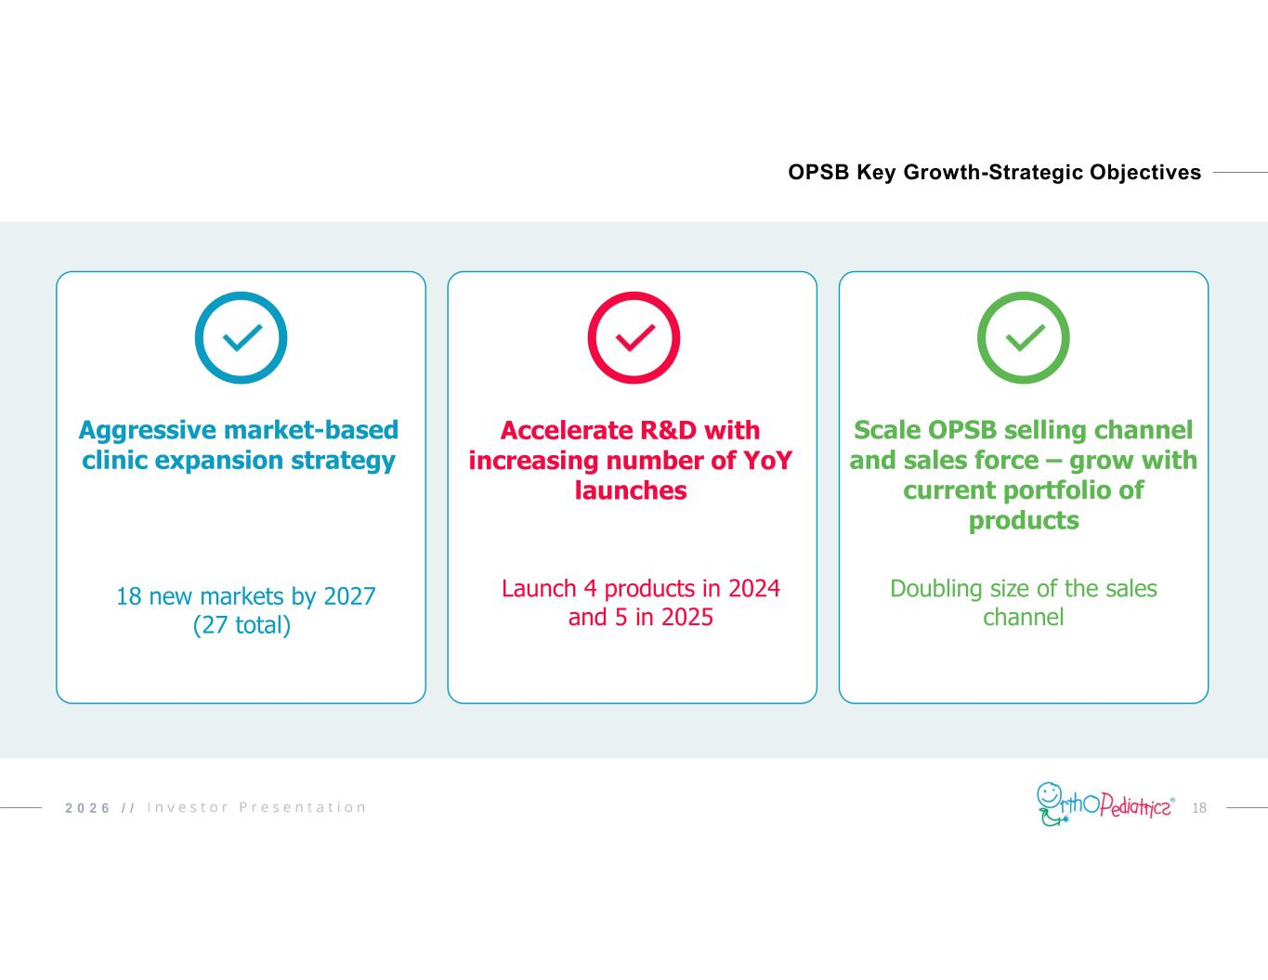
182 0 2 6 / / OPSB Key Growth-Strategic Objectives Aggressive market-based clinic expansion strategy Accelerate R&D with increasing number of YoY launches Scale OPSB selling channel and sales force – grow with current portfolio of products Launch 4 products in 2024 and 5 in 2025 18 new markets by 2027 (27 total) Doubling size of the sales channel

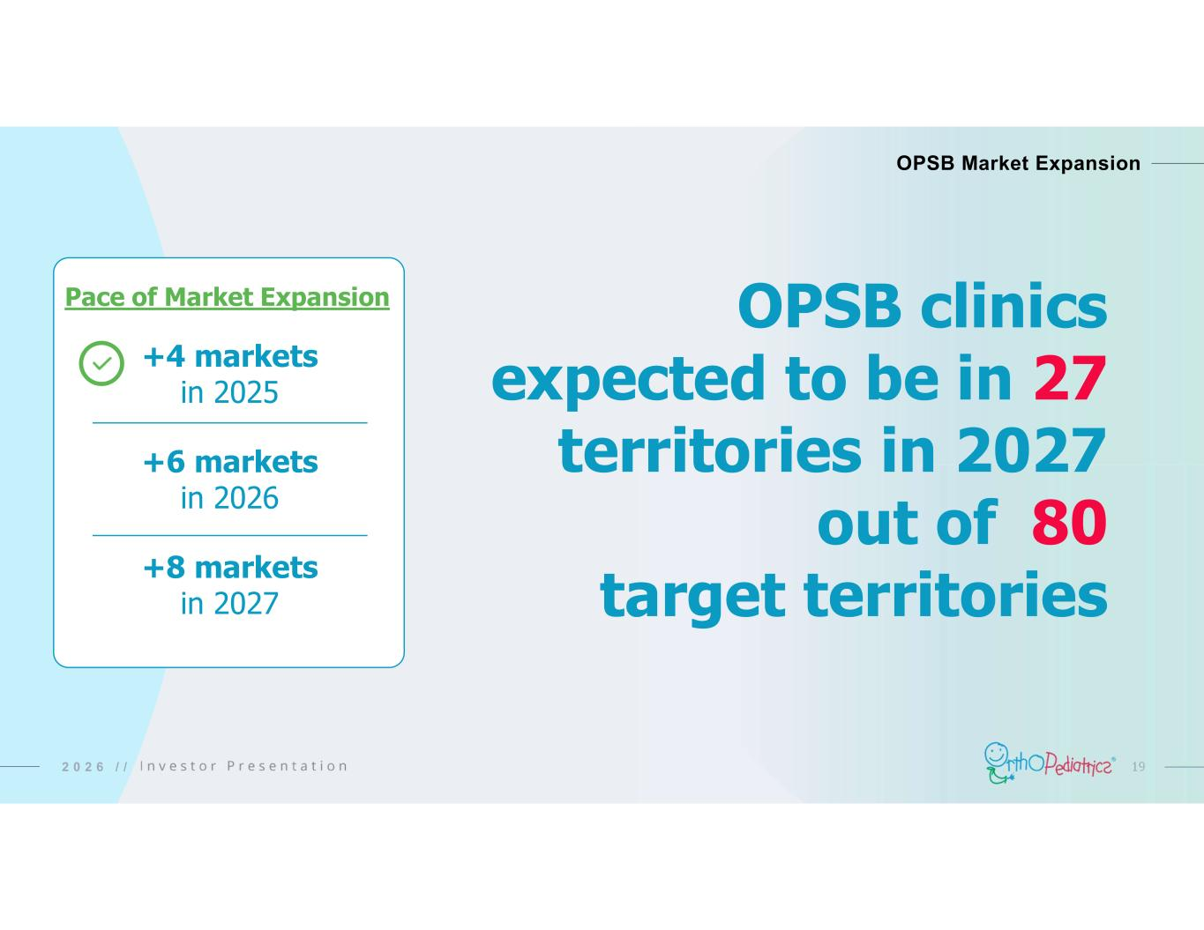
192 0 2 6 / / OPSB Market Expansion Pace of Market Expansion +4 markets in 2025 +6 markets in 2026 +8 markets in 2027 OPSB clinics expected to be in 27 territories in 2027 out of 80 target territories

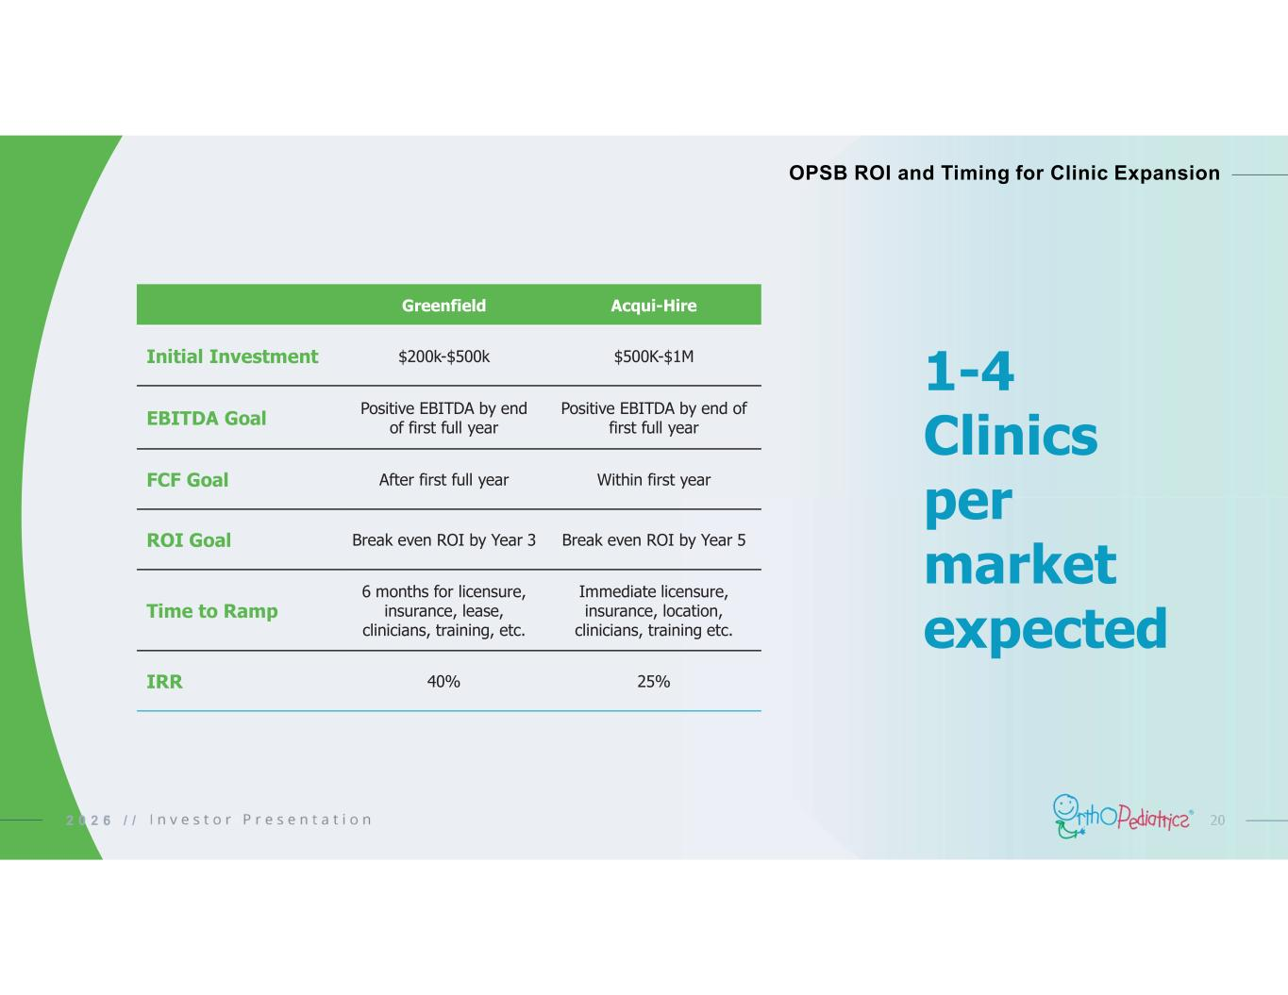
202 0 2 6 / / OPSB ROI and Timing for Clinic Expansion 1-4 Clinics per market expected Acqui-HireGreenfield $500K-$1M$200k-$500kInitial Investment Positive EBITDA by end of first full year Positive EBITDA by end of first full yearEBITDA Goal Within first yearAfter first full yearFCF Goal Break even ROI by Year 5Break even ROI by Year 3ROI Goal Immediate licensure, insurance, location, clinicians, training etc. 6 months for licensure, insurance, lease, clinicians, training, etc. Time to Ramp 25%40%IRR 5

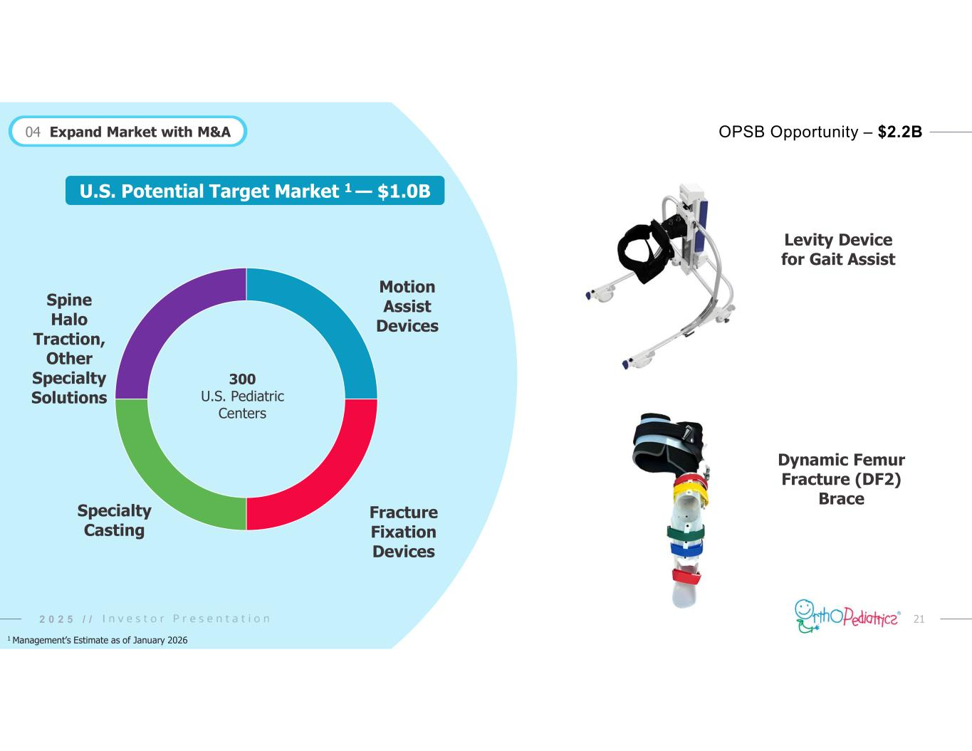
212 0 2 6 / / Motion Assist Devices Fracture Fixation Devices Specialty Casting Spine Halo Traction, Other Specialty Solutions 300 U.S. Pediatric Centers U.S. Potential Target Market 1 — $1.0B OPSB Opportunity – $2.2B 2 0 2 5 / / 1 Management’s Estimate as of January 2026 Levity Device for Gait Assist Dynamic Femur Fracture (DF2) Brace 04 Expand Market with M&A

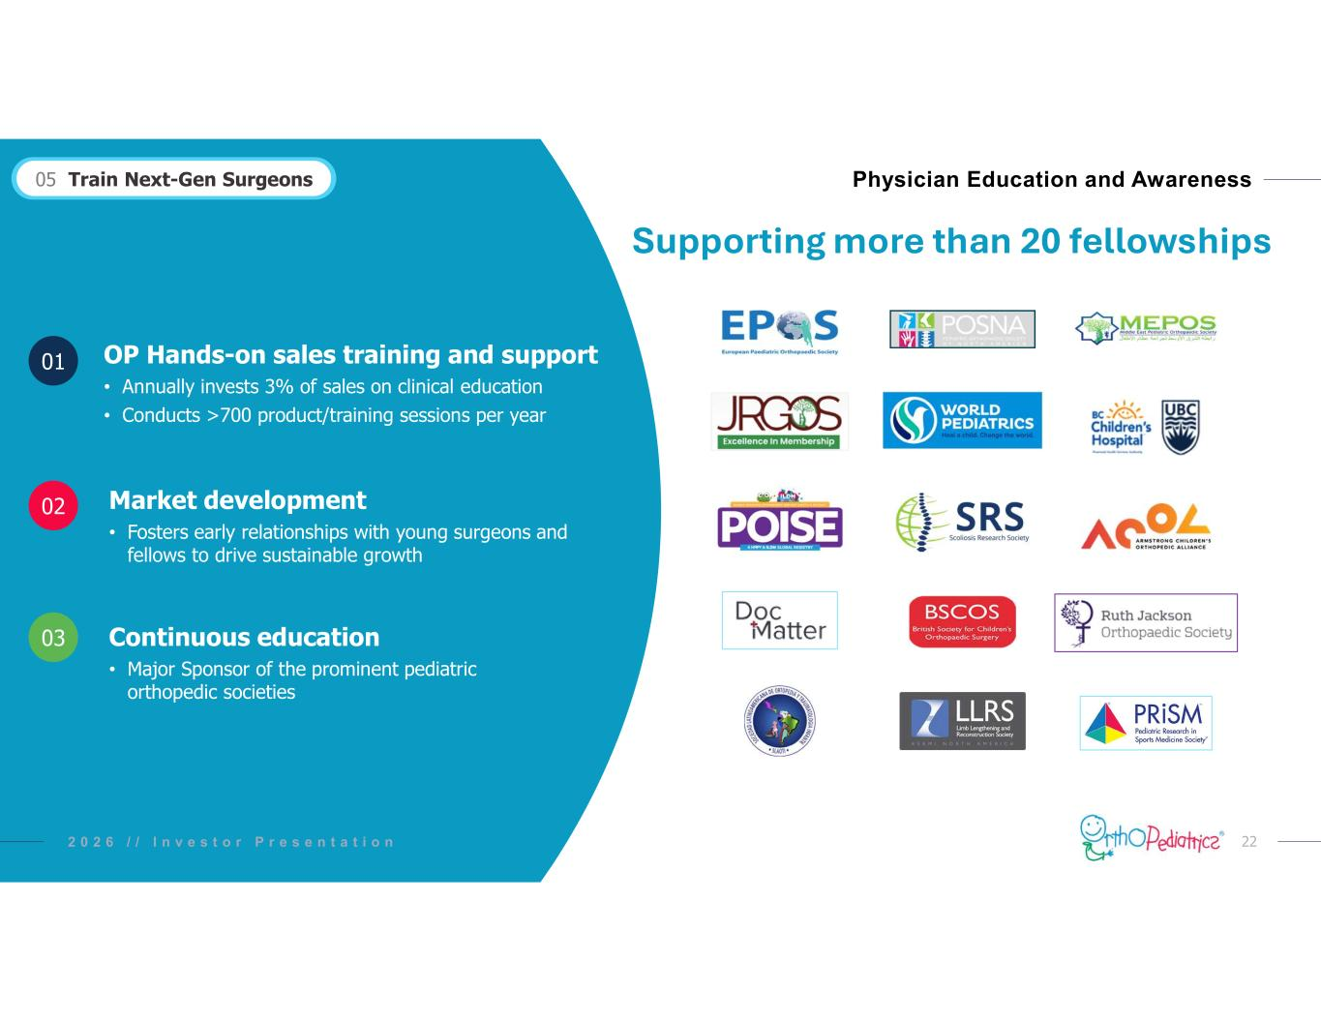
222 0 2 6 / / Physician Education and Awareness OP Hands-on sales training and support • Annually invests 3% of sales on clinical education • Conducts >700 product/training sessions per year Continuous education • Major Sponsor of the prominent pediatric orthopedic societies Market development • Fosters early relationships with young surgeons and fellows to drive sustainable growth 02 03 01 05 Train Next-Gen Surgeons I n v e s t o r P r e s e n t a t i o n Supporting more than 20 fellowships

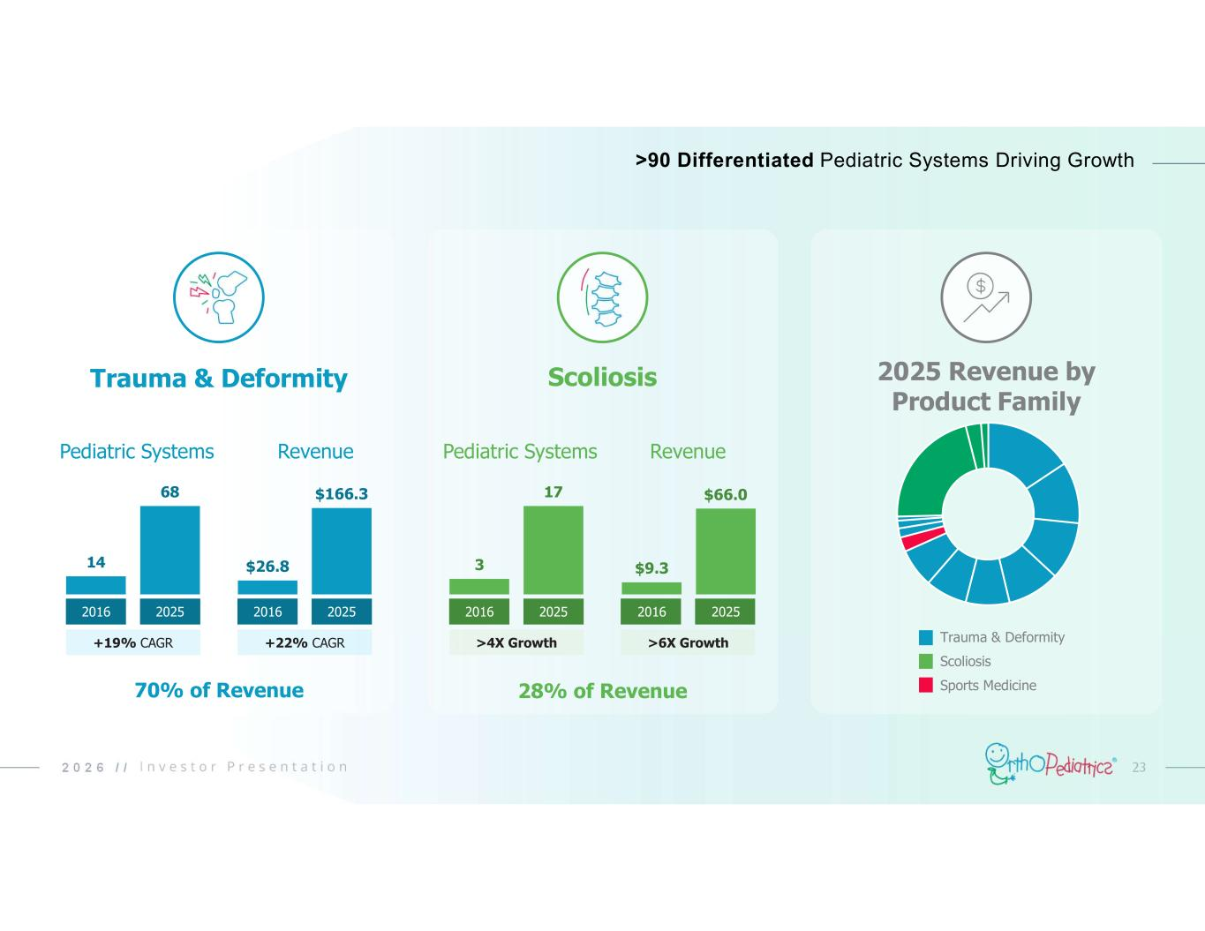
232 0 2 6 / / Trauma & Deformity +19% CAGR 14 68 2016 2025 $26.8 $166.3 2016 2025 Pediatric Systems Revenue +22% CAGR Scoliosis >4X Growth 3 17 2016 2025 $9.3 $66.0 2016 2025 Pediatric Systems Revenue >6X Growth 2025 Revenue by Product Family Trauma & Deformity Scoliosis Sports Medicine70% of Revenue 28% of Revenue >90 Differentiated Pediatric Systems Driving Growth

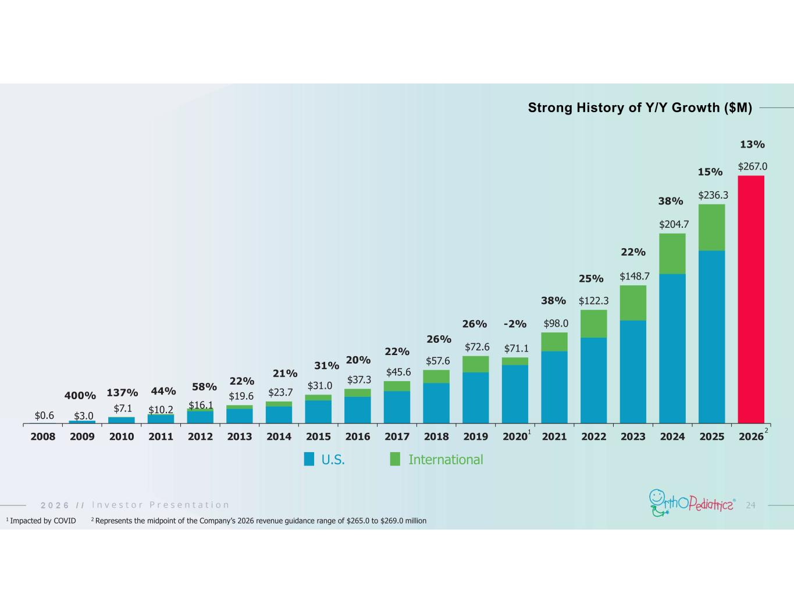
242 0 2 6 / / $0.6 $3.0 $7.1 $10.2 $16.1 $19.6 $23.7 $31.0 $37.3 $45.6 $57.6 $72.6 $71.1 $98.0 $122.3 $148.7 $204.7 $236.3 $267.0 2008 2009 2010 2011 2012 2013 2014 2015 2016 2017 2018 2019 2020 2021 2022 2023 2024 2025 2026 Strong History of Y/Y Growth ($M) 400% 137% 44% 58% 22% 21% 31% 20% 22% 26% 26% -2% 38% U.S. International 1 25% 1 Impacted by COVID 22% 38% 2 Represents the midpoint of the Company’s 2026 revenue guidance range of $265.0 to $269.0 million 15% 2 13%

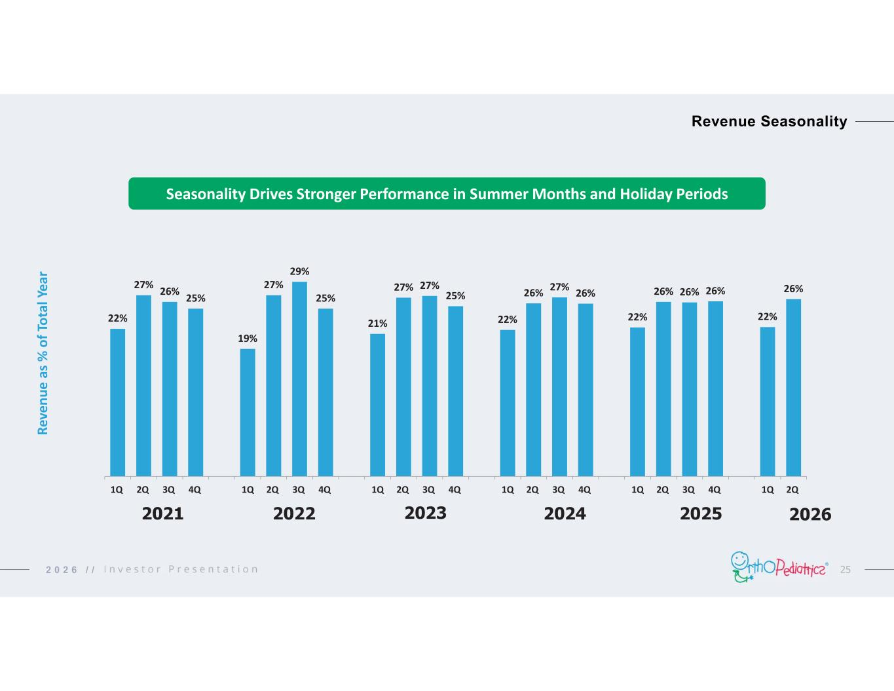
252 0 2 6 / / Seasonality Drives Stronger Performance in Summer Months and Holiday Periods 22% 27% 26% 25% 19% 27% 29% 25% 21% 27% 27% 25% 22% 26% 27% 26% 22% 26% 26% 26% 22% 26% 1Q 2Q 3Q 4Q 1Q 2Q 3Q 4Q 1Q 2Q 3Q 4Q 1Q 2Q 3Q 4Q 1Q 2Q 3Q 4Q 1Q 2Q Re ve nu e as % o f T ot al Y ea r 2021 2022 2023 Revenue Seasonality 2024 2025 2026

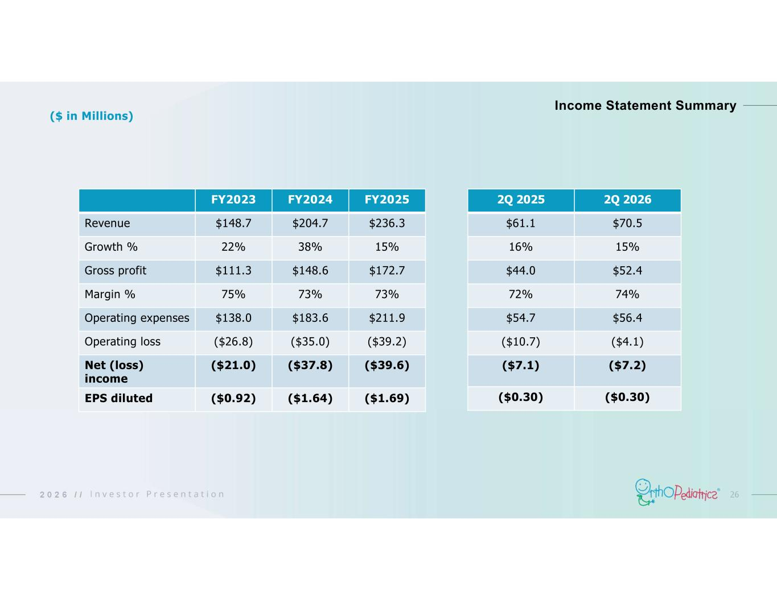
262 0 2 6 / / FY2025FY2024FY2023 $236.3$204.7$148.7Revenue 15%38%22%Growth % $172.7$148.6$111.3Gross profit 73%73%75%Margin % $211.9$183.6$138.0Operating expenses ($39.2)($35.0)($26.8)Operating loss ($39.6)($37.8)($21.0)Net (loss) income ($1.69)($1.64)($0.92)EPS diluted Income Statement Summary ($ in Millions) 2Q 20262Q 2025 $70.5$61.1 15%16% $52.4$44.0 74%72% $56.4$54.7 ($4.1)($10.7) ($7.2)($7.1) ($0.30)($0.30)

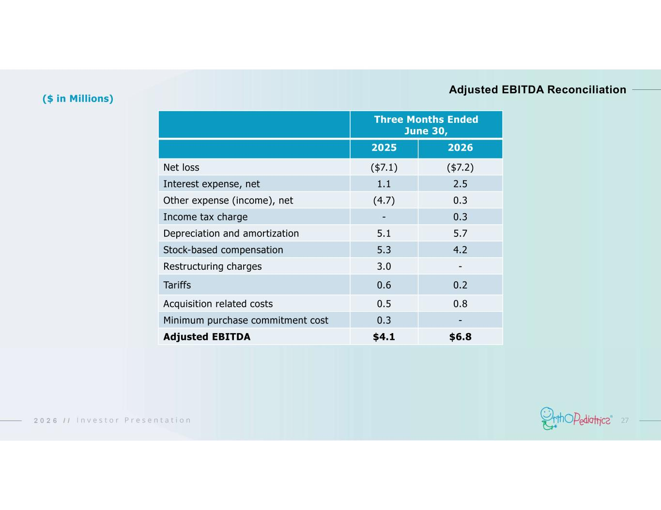
272 0 2 6 / / Adjusted EBITDA Reconciliation Three Months Ended June 30, 20262025 ($7.2)($7.1)Net loss 2.51.1Interest expense, net 0.3(4.7)Other expense (income), net 0.3-Income tax charge 5.75.1Depreciation and amortization 4.25.3Stock-based compensation -3.0Restructuring charges 0.20.6Tariffs 0.80.5Acquisition related costs -0.3Minimum purchase commitment cost $6.8$4.1Adjusted EBITDA ($ in Millions)

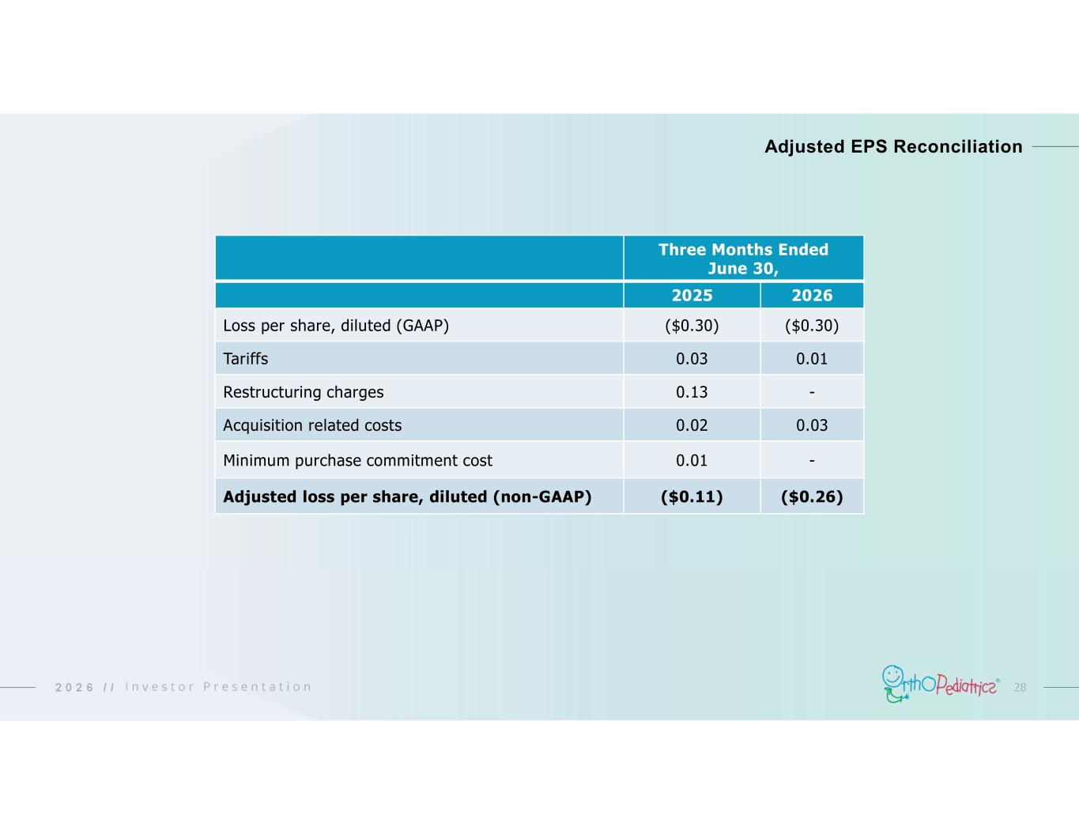
282 0 2 6 / / Adjusted EPS Reconciliation Three Months Ended June 30, 20262025 ($0.30)($0.30)Loss per share, diluted (GAAP) 0.010.03Tariffs -0.13Restructuring charges 0.030.02Acquisition related costs -0.01Minimum purchase commitment cost ($0.26)($0.11)Adjusted loss per share, diluted (non-GAAP)

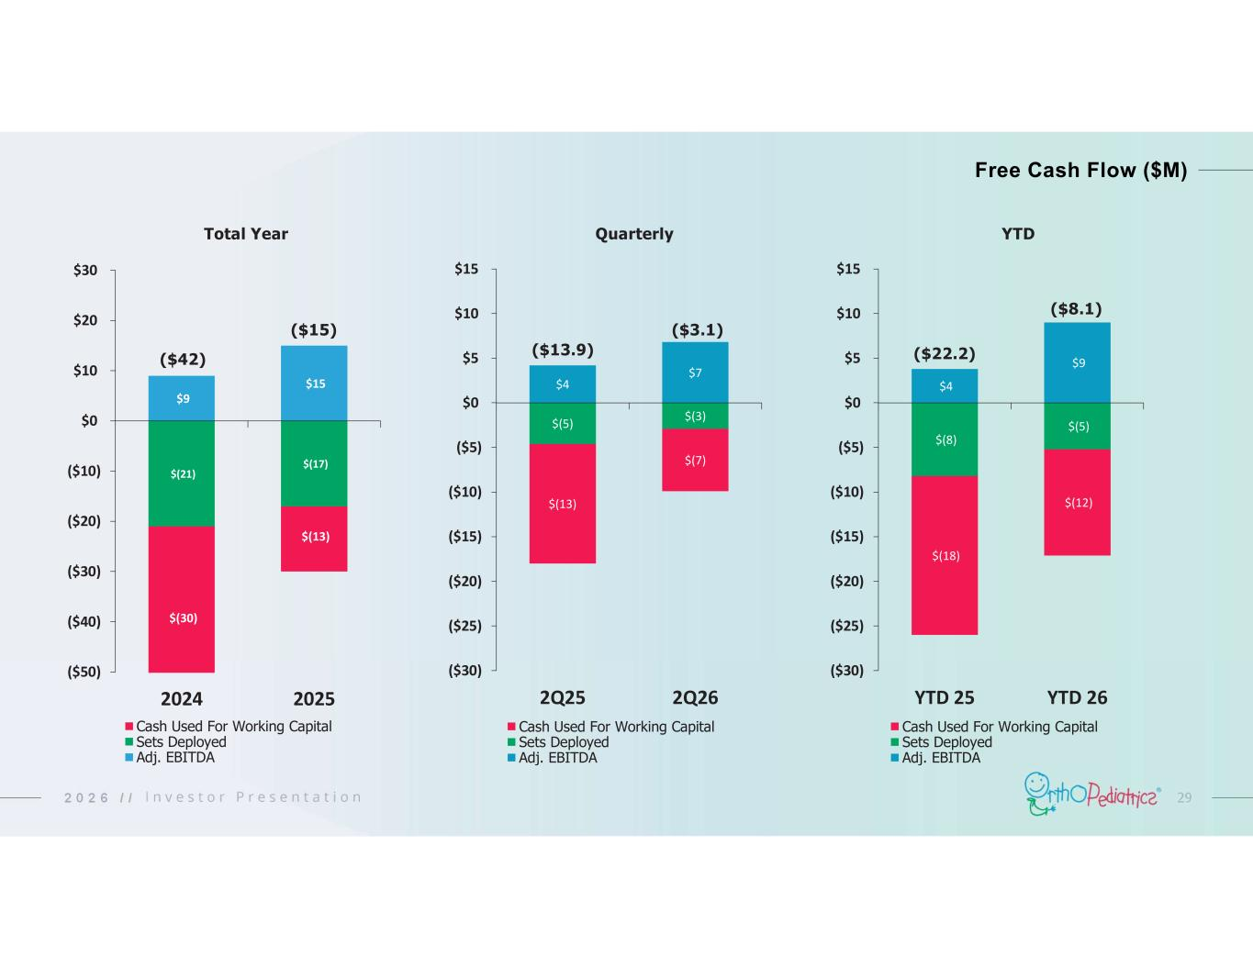
292 0 2 6 / / Free Cash Flow ($M) $9 $15 $(21) $(17) $(30) $(13) ($50) ($40) ($30) ($20) ($10) $0 $10 $20 $30 2024 2025 Cash Used For Working Capital Sets Deployed Adj. EBITDA ($42) ($15) $4 $7 $(5) $(3) $(13) $(7) ($30) ($25) ($20) ($15) ($10) ($5) $0 $5 $10 $15 2Q25 2Q26 Cash Used For Working Capital Sets Deployed Adj. EBITDA ($13.9) ($3.1) Total Year Quarterly $4 $9 $(8) $(5) $(18) $(12) ($30) ($25) ($20) ($15) ($10) ($5) $0 $5 $10 $15 YTD 25 YTD 26 Cash Used For Working Capital Sets Deployed Adj. EBITDA YTD ($8.1) ($22.2)

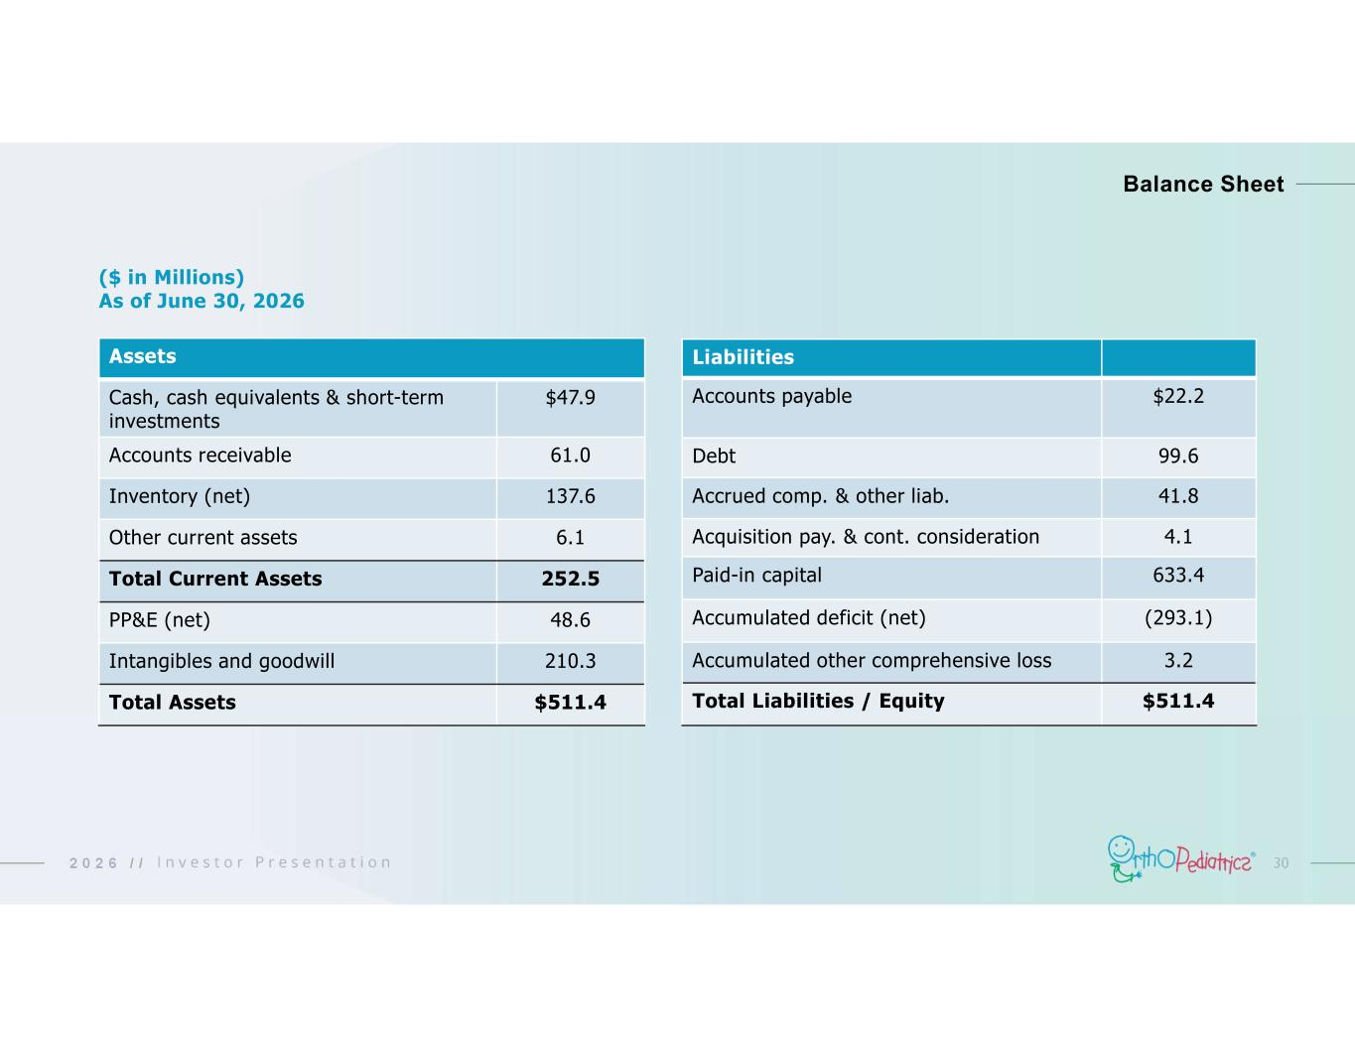
302 0 2 6 / / Balance Sheet Assets $47.9Cash, cash equivalents & short-term investments 61.0Accounts receivable 137.6Inventory (net) 6.1Other current assets 252.5Total Current Assets 48.6PP&E (net) 210.3Intangibles and goodwill $511.4Total Assets Liabilities $22.2Accounts payable 99.6Debt 41.8Accrued comp. & other liab. 4.1Acquisition pay. & cont. consideration 633.4Paid-in capital (293.1)Accumulated deficit (net) 3.2Accumulated other comprehensive loss $511.4Total Liabilities / Equity ($ in Millions) As of June 30, 2026

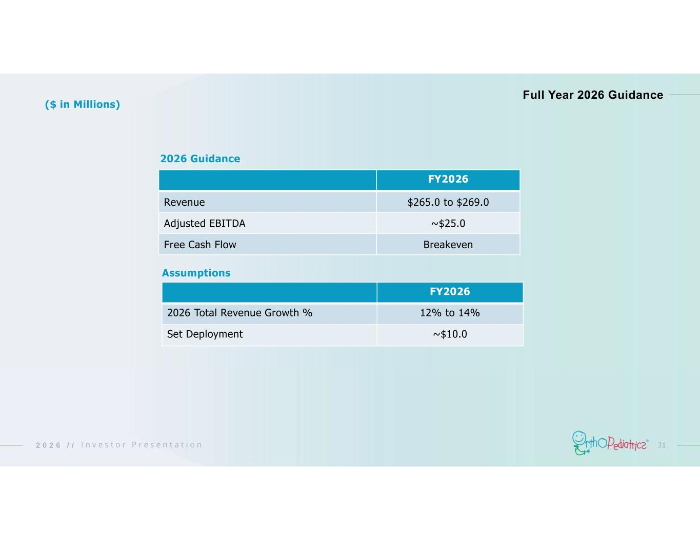
312 0 2 6 / / 2026 Guidance FY2026 $265.0 to $269.0Revenue ~$25.0Adjusted EBITDA BreakevenFree Cash Flow FY2026 12% to 14%2026 Total Revenue Growth % ~$10.0Set Deployment Assumptions Full Year 2026 Guidance ($ in Millions)

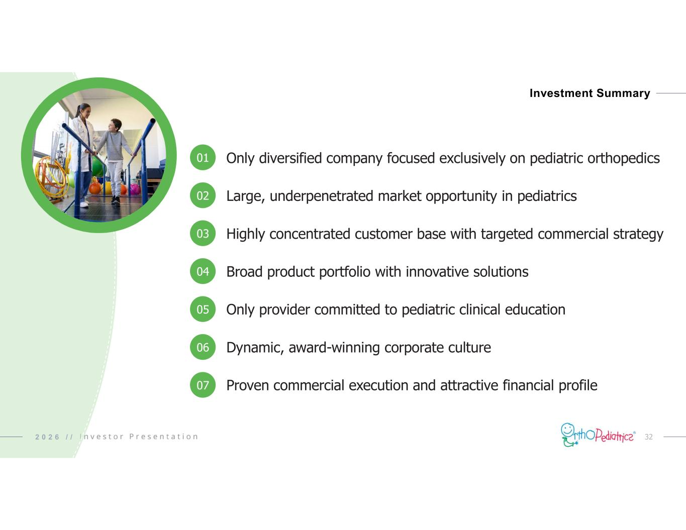
322 0 2 6 / / Investment Summary Only diversified company focused exclusively on pediatric orthopedics Large, underpenetrated market opportunity in pediatrics Highly concentrated customer base with targeted commercial strategy Broad product portfolio with innovative solutions Only provider committed to pediatric clinical education Dynamic, award-winning corporate culture Proven commercial execution and attractive financial profile 01 04 02 05 03 06 07

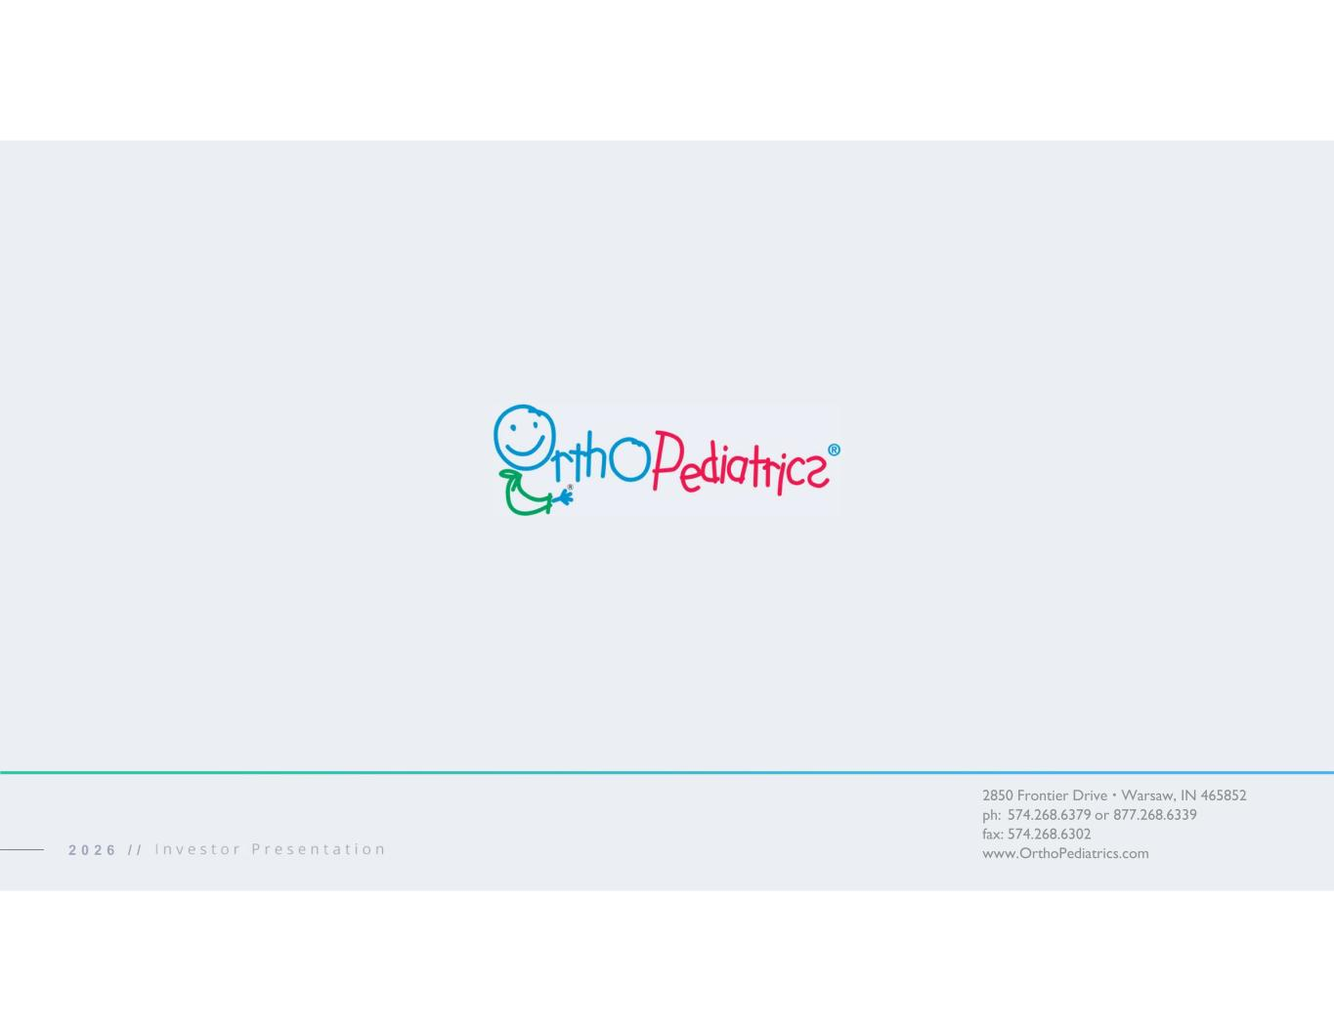
2850 Frontier Drive  Warsaw, IN 465852 ph: 574.268.6379 or 877.268.6339 fax: 574.268.6302 www.OrthoPediatrics.com2 0 2 6 / /

